**Steps for Code Execution and Development**

Here’s the list of python libraries, that are needed at first,

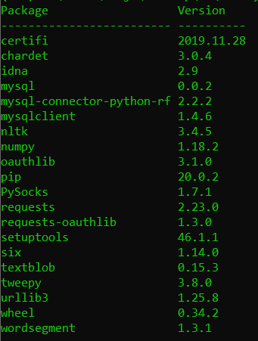

0. Before running below python file in local, please create a database and table in your MySQL DB.

* Create a database, whose name should be – “***world***”
* Create a table inside world database as - “***tweet_dataset***”
* Here’s the list of columns
  + t,
  + u,
  + w,
  + hashtag,
  + mention,
  + id(pk)]
* Here’s the screenshot,

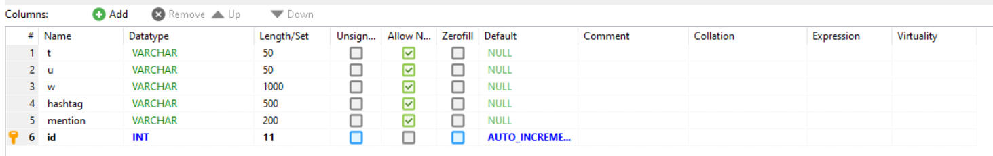

**Once above steps are done,**

1. Steps to follow to execute "***inserData***" python file

open insertData file in a python editor

Visit Line # 30 –

with open("<YourLocalDirectory>\\PopularTweet\\datasets\\<CHOSE_A_FILE_NAME_FROM_DATASETS_FOLDER.txt> ", "r", encoding='utf-8') as dataContent:

Therefore, it should look like,

with open("C:\\Users\\sanja\\Desktop\\FL\\PopularTweet\\datasets\\test1-1000.txt>", "r", encoding='utf-8') as dataContent:

Once done, Follow the below steps,

a. Open Terminal/Cmd prompt

b. go to “/***src***/” directory

c***. python insertData.py***

Here’s the screenshot.

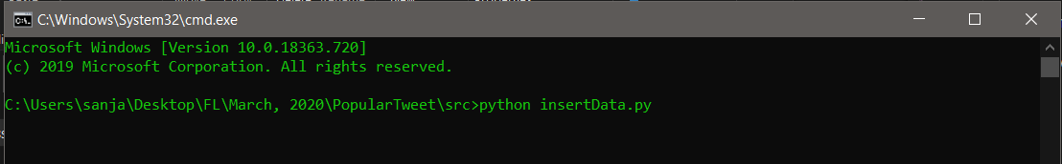

Click “***Enter***” the above command will start executing/inserting your data sets in your DB.

Note: Each .txt file in dataset/ has thousands of data, therefore, once all data in a file execution gets completed, open the insertData.py again and give other text file which isn’t executed.